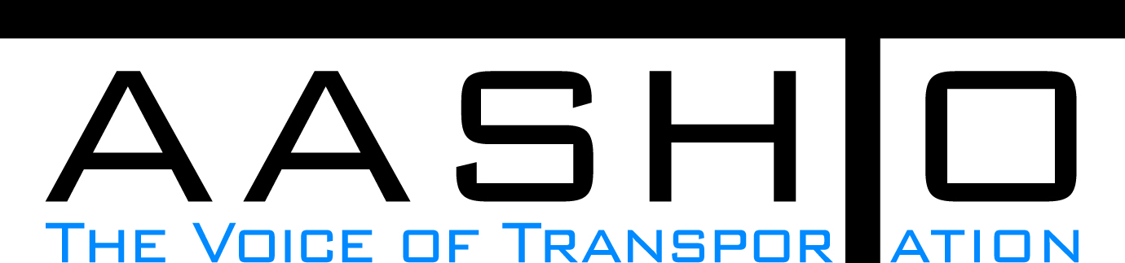Domestic Scan Proposal Form
AASHTO is soliciting topic proposals for a Calendar Year 2013 US Domestic Scan Program (NCHRP Panel 20-68A). Each selected scan topic will be investigated through site visits to three to six locations for approximately a two week period or less (type 1), by webinar (type 2) or peer exchange (type 3) conducted by a group of eight to 12 transportation professionals with expertise in the selected topic area. Proposed topics should meet the following criteria:
- Address an important and timely need for information by transportation agencies;
- Are of interest to a broad national spectrum of people and agencies;
- Are complex and also “hands-on,” meaning they lend themselves particularly well to exploration through on-site visits; and
- Are sufficiently focused that the tour participants are able to investigate and understand key issues in the limited time available on the tour.
This form is designed to collect the full length of your proposal. Sections requiring essays have unlimited space for you to use. Contact information has some limited text. Use your TAB key to advance to the area where you need to complete information.
Proposals should be returned no later than OCTOBER 15, 2012.
Proposal Contact Information
Name | Jennifer Toth | Address | 206 S. 17th Ave., MD 102A  Phoenix, AZ 85007
Title | State Engineer | E-mail | Jtoth@azdot.gov
Member Department | Arizona | Telephone number | 602-712-7391
AASHTO Committee | Standing Committee on Highways | Date of submission | 10/10/2012

Title of Proposed Scan

Best Management Practices For Developing A Cross-Trained Operations Workforce

Problem Statement (What topic is to be examined? What drives the need for the scan? Why now?)
Nationally, DOT operations and capital budgets are constrained or decreasing. There is an increasing need for DOT organizations to be more efficient with limited resources such as our maintenance and construction workforces. A cross-trained workforce can be more efficient and agile in adapting to changing missions, priorities and budgets.

Scan Scope (What specific subject areas are to be examined? Which cities and states might be visited? Which agencies/organizations (including specific departments or types of staff if applicable)?
The scope may include: Position/job descriptions, training and certification requirements, successful strategies and barriers to implementation. This Scan would best be accomplished through a peer exchange (Type 3). HR and operations representatives from state DOTs that have been successful with a cross-trained operations workforce could present their programs to the Scan team at a single location. This concept was very successful with other Scans such as the Performance Measures for Highway Maintenance and Preservation.

Anticipated Scan Results (What key information is to be gained? What information is to be shared after the scan? Who would the audience be for this information?)
Identification of best practices and the conditions under which each is applicable/best suited. Examples of successful cross-training programs, position descriptions, and implementation strategies. The audience may include maintenance engineers, construction engineers and operations personnel and management.

Benefits Expected (Including potential impacts on current technology or procedures)
Implementation of Scan results could make DOT operations workforces more cost efficient, more technically proficient, and more able to adapt to changing conditions.

